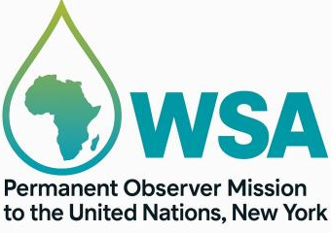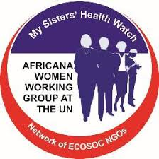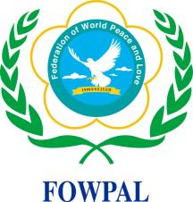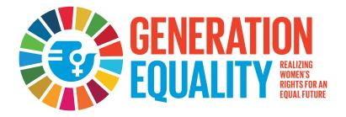
Restoring Trust: Managing Transformation, UN81 Initiative
2026 United Nations Day of Peace: First Ladies Becoming High-Level Forum
Tuesday September 22,2026
6:00PM -10:00PM
Theme: First Ladies Becoming Agents for Peace: Prioritizing Women as Key Players in Promoting Global Peace and Development.
The United Nations Delegate Dinning

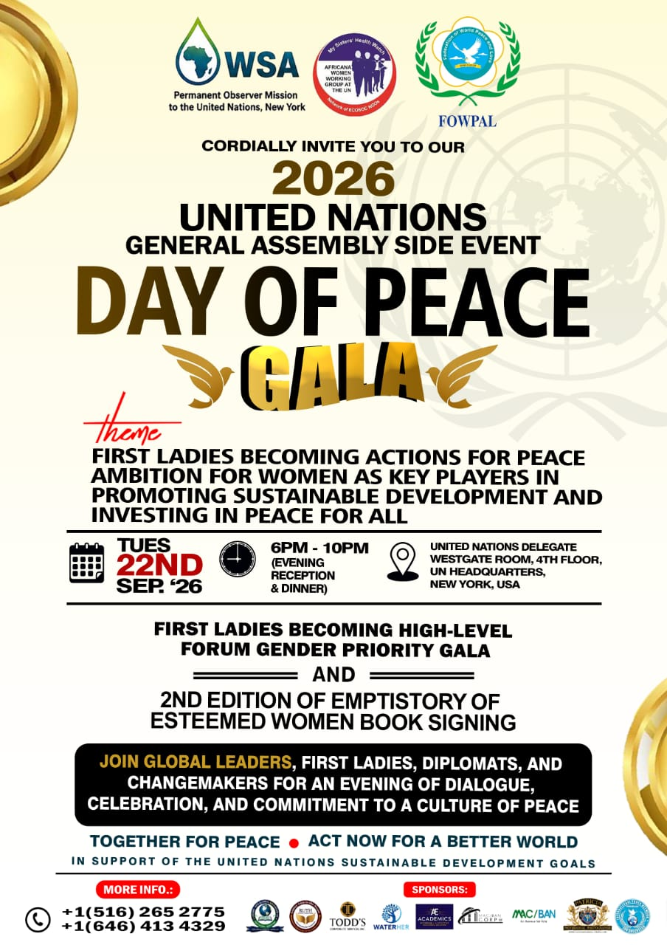In 1981, the United Nations General Assembly declared the third Tuesday of September as the International Day of Peace. This day coincided with the opening day of the annual sessions of the General Assembly. The purpose of the day is to strengthen the ideals of peace and harmony around the world.

Since 2010, our organization, with UN ECOSOC NGOs on Gender Equality, the Africana Women Working Group at the UN, has continued to advance the cause of women in leadership positions through our program, First Ladies Becoming High-Level Forum on SDG-16 and Targets, to bring global awareness to the most needed roles of First Ladies of Nations in women and peace.

In the words of United Nations Secretary-General António Guterres, “Peace is needed today more than ever. War and conflict are unleashing devastation, poverty, and hunger, and driving tens of millions of people from their homes. Climate chaos is all around. And even peaceful countries are gripped by gaping inequalities and political polarization.” Women, especially First Ladies of Nations, have a significant role to play, and we are committed to this cause with our passionate commitment to achieving a peaceful society.

The United Nations Day of Peace, observed annually, serves as a global reminder of humanity’s collective responsibility to foster peace, justice, and sustainable development. In 2026, the world continues to face complex conflicts, humanitarian crises, gender-based violence, and widening inequalities. These challenges demand leadership that is compassionate, strategic, and transformative.
Across continents, First Ladies have emerged as influential voices in shaping national priorities, advocating for vulnerable populations, and mobilizing communities toward peacebuilding and development. Their unique positioning at the intersection of political influence, social advocacy, and cultural diplomacy makes them indispensable actors in advancing global peace.
Yet, despite their contributions, women remain underrepresented in peace negotiations, conflict prevention mechanisms, and national development planning. The 2026 UN Day of Peace presents a timely opportunity to elevate First Ladies as Agents for Peace, while reinforcing the global commitment to women’s leadership as a cornerstone of sustainable peace and development.
Observer Mission of pan African Intergovernmental Agency on Water and Sanitation for Africa to the United Nations, Africana Women Working Group (AWWG) and the Federation of World Peace and Love (FOWPAL) are jointly convening this high-level event to amplify women’s voices, strengthen cross-border collaboration, and promote gender-responsive peacebuilding frameworks non the theme: “First Ladies Becoming Agents for Peace: Prioritizing Women as Key Players in Promoting Global Peace and Development”
This theme recognizes:
- The strategic influence First Ladies hold in shaping national and regional peace agendas.
- The transformative role women play in conflict prevention, mediation, and post-conflict reconstruction.
- The need to institutionalize women’s leadership within global peace and development frameworks.
- The urgency of gender-inclusive policies to address insecurity, displacement, poverty, and violence.
The theme aligns with:
- UN Security Council Resolution 1325 on Women, Peace, and Security
- SDG 5 (Gender Equality)
- SDG 16 (Peace, Justice, and Strong Institutions)
- SDG 17 (Partnerships for the Goals)
The purpose is to discuss women’s role as key players in GEPS (Gender Priority Strategy)
This entails:
- Review of Gender Actions on SDG 16 and Targets
- Women work to address the challenges and gaps in advancing gender equality.
- Generation Equality and Ambition for First Ladies, linked to promoting sustainable development.
- Conversations with First Ladies and their key role as key players in the Gender Priority Strategy, in promoting global peace.
- Gender Priority Strategy GEPS Action Model on gender actions for peace.
To strengthen the role of First Ladies and women leaders as catalysts for peace, development, and global cooperation.

Specific Objectives
- Highlight the contributions of First Ladies in advancing peace, humanitarian support, and national unity.
- Promote gender-responsive peacebuilding strategies across Africa, the Caribbean, Europe, Asia, and the Americas.
- Facilitate dialogue between First Ladies, diplomats, UN agencies, civil society, and youth leaders.
- Showcase successful models of women-led peace initiatives and community development programs.
- Strengthening the visibility of WSA-WATERHer, AWWG-GEPS and FOWPAL as global conveners of women’s leadership and peace advocacy.

Implications for WATERHer
WATERHer stands at the intersection of gender, peace, climate resilience, and water governance making First Ladies ideal global champions for the initiative.

Positioning WATERHer as a Peacebuilding Mechanism: Water insecurity is a driver of conflict, displacement, and gender inequality. By empowering women as water leaders, WATERHer directly contributes to conflict prevention, community stability and peaceful resource management in alliance for women-led climate and water resilience.

Leveraging First Ladies as High-Level Advocates: First Ladies can champion WATERHer at global peace platforms, mobilize national governments to adopt women-led water governance, integrate WATERHer into national resilience strategies, use their convening power to secure funding and partnerships. This mirrors the global forum’s roadmap for First Ladies as pillars of peace.

Embedding WATERHer in Gender-Peace Frameworks: WATERHer can be framed as a Women, Peace & Security (WPS) intervention by training women in conflict-sensitive water management, establishing women-led community water hubs, supporting peace dialogues around shared water resources and create a First Ladies WATERHer Coalition

Expected Outcomes
- A Joint Declaration on Women as Agents for Peace, endorsed by participating First Ladies and partners.
- Strengthened networks among First Ladies, women leaders, and peacebuilding organizations.
- Policy recommendations for integrating women’s leadership into national peace and development agendas.
- Commitments to community-level peace initiatives, especially those involving youth and women.
- Increased global visibility for WSA WATERHER, AWWG-GEPS and FOWPAL as champions of peace diplomacy.
The outcome of the event will ignite action to further the GEPS on Gender Actions for Peace by partnering with First Ladies to become pillars of a sustainable world. Peace is possible in our lifetime through global citizens working in unity and harmony. Since the establishment of the United Nations and the creation of the Charter of the United Nations, member states have a responsibility to work towards achieving the agenda for 2030 on Leaving No One Behind.

Life is better in a world where peace exists, and today, we look to those who have been peacemakers and peacekeepers to learn what we can each do individually to make the world a more peaceful place, as well as to advance the Gender Priority Strategy as women.

Program Format:
Opening remarks and Call to 2026 UN Day of Peace.
The Africana Women Working Group at the UN, the Permanent Observer Mission of the Pan African Intergovernmental Agency for Water and Sanitation to the United Nations

Welcome song and dance by Volunteers

Review of Gender Actions on SDG 16 and Targets
- Special Guest Speakers
- Theme: First Ladies Becoming Agents for Peace: Prioritizing Women as Key Players in Promoting Global Peace and Development.

Challenges and gaps in advancing gender equality for women and peace.
- Gender and peace advocates

Generation Equality and Ambition for First Ladies, linked to promoting sustainable development.
- Presentation from First Ladies

WATERHer: A strategic peacebuilding mechanism with First Ladies and their key role as key players in the Gender Priority Strategy for promoting global peace.
- First Ladies Session

Gender Priority Strategy (GEPS) Action Model on gender actions for peace.
- Gender Priority Strategy Ambassadors sharing

Dancers and Bell Ceremony

2026 Culture of Peace for Peace Advocates, Women, and Girls: Ring the Peace Bell
First Ladies and Esteemed Persons to Ring the Peace Bell and Presentation of Peace Awards

Presentation and Decoration of Fellow Gender Priority Strategy FGEPS

Unveiling of First Ladies WATERHer Coalition to champion global action on Peace Building

Restoring Trust: Managing Transformation, UN81 Initiative: UN Day of Peace Clarion Call to Action

Closing Remarks

Lunch, sharing, conversation, and networking.

